[question 1]

A sample question, using *emphasized* and **bold** text. You can use superscript as in 102 and subscripts as in Ax.

This question includes a simple table:

|  |  |  |
| --- | --- | --- |
| **Column 1** | **Column 2** | **Column 3** |
| Value a | Value b | Value c |
| Value d | Value e | Value f |

Which of the following is the correct alternative?

[alternatives]

- text for alternative 1

- text for alternative 2

- text for alternative 3

+ text for alternative 4 (this is the correct alternative!)

- text for alternative 5

[question 2]

This question uses an image:

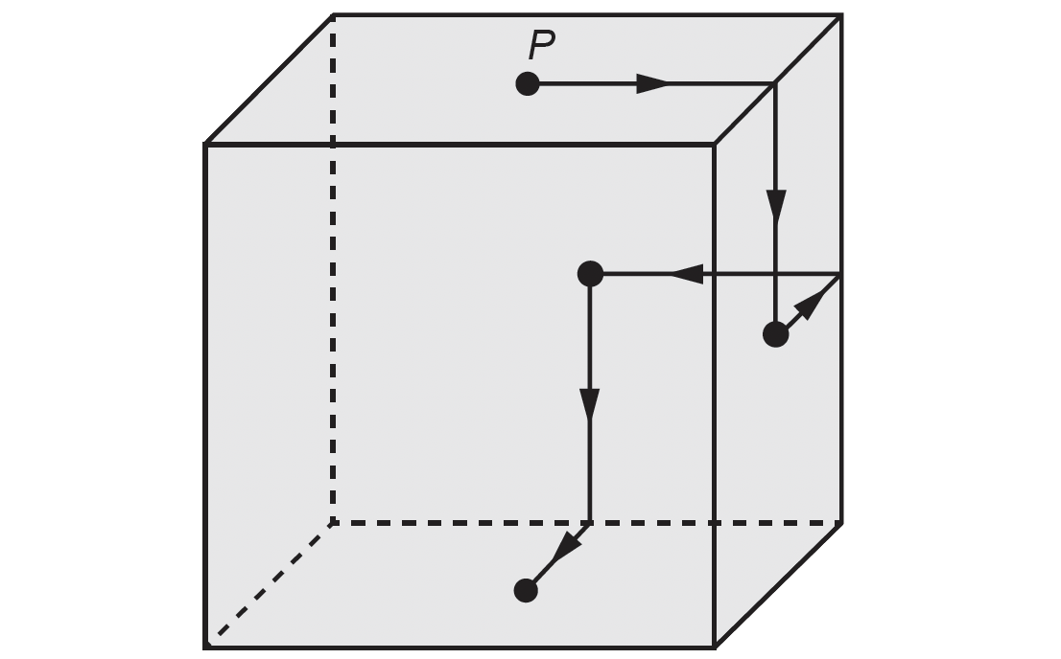

Notice that images are printed as large as possible within the column while preserving their original aspect ratio. If you want the image to appear smaller, add blank space to its sides:



Considering the figures above, what is the correct answer?

[alternatives]

- Alternative 1

+ Alternative 2

- Alternative 3

- Alternative 4

- Alternative 5

[question 3]

<title>This is a centered title</title>

<indent>This is an indented paragraph

It can be used to display poetry

This is how a very very long line is displayed as an indented paragraph.

</indent>

<title2>This is a left-indented title</title2>

<boxed> This is a boxed paragraph. It can be used to display tips or to call for attention.

</boxed>

<noindent/>What is the ideal time to read poetry? The alternatives will be typeset in two columns, as the tag "[alternatives2]" is specified.

[alternatives2]

+ At dusk

- In the morning

- At noon

- During a storm

- At night

[question 4]

This question uses images in the alternatives.

Which of the following is the correct image?

[alternatives2]

- 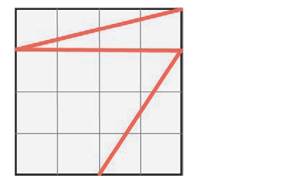

- 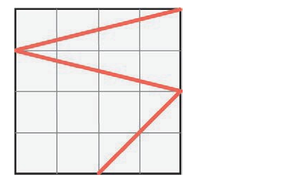

- 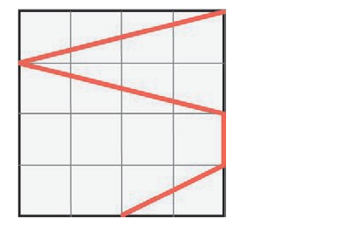

-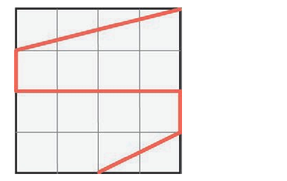

+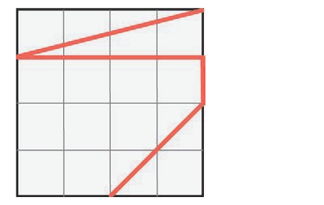

[question 5]

This question uses some mathematical expressions: <expr height="90%">2\pi\sqrt{3}</expr> e <expr height="240%">\frac{2\pi\sqrt{3}}{a^2}</expr>.

Which is the correct answer?

[alternatives2]

- <expr height="240%">\frac{2\pi\sqrt{3}}{a^2}</expr>

- <expr height="240%">\frac{x_{2} + y_{1}^{2} }{a^2}</expr>

+ <expr height="240%">\frac{\sqrt{2\pi}}{a^2} + x^{2}</expr>

- <expr height="210%">\frac{5}{32}</expr>

- <expr height="90%">\sqrt{3a^{x}}</expr>